Course 1 - Lesson 4,5 - CI with Jenkins + TDD

# Distributed Jenkins



# Jenkins Lab notes

If you run into 'database locked issues' you can try rebooting the machine

sudo reboot

To start jenkins manually

sudo /etc/init.d/jenkins start

# Lab : jenkins + git + Maven

Step 3 when configuring the tools

JDK

Name : localJDK

JAVA_HOME : /usr/lib/jvm/java-8-openjdk-amd64/

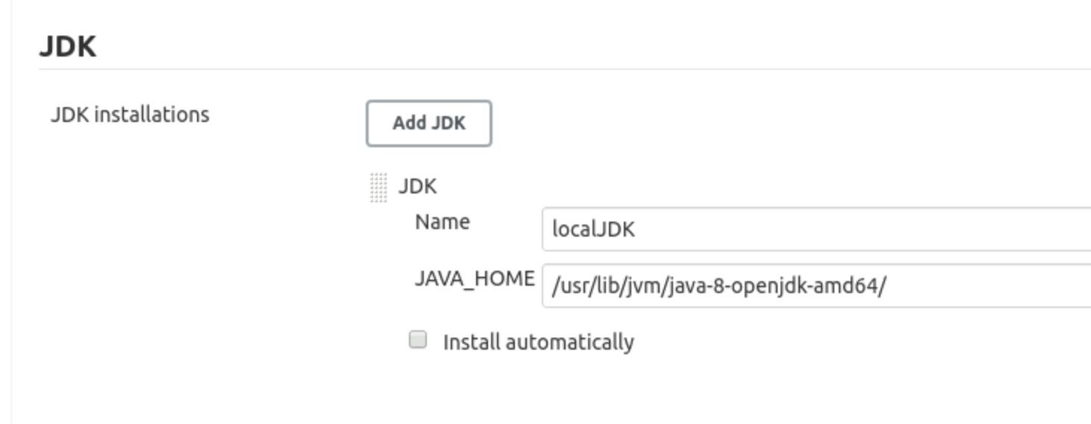

Git

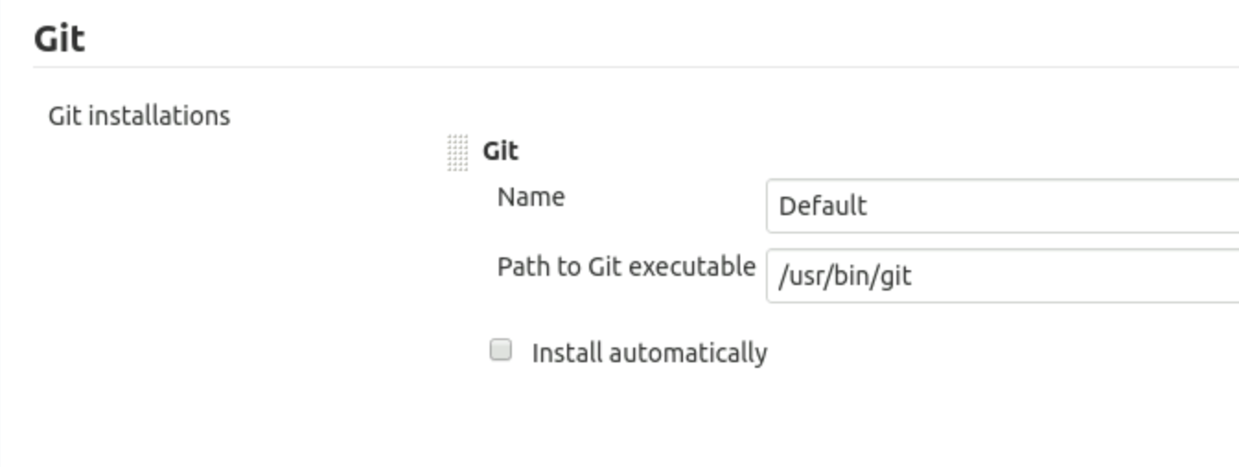

Maven

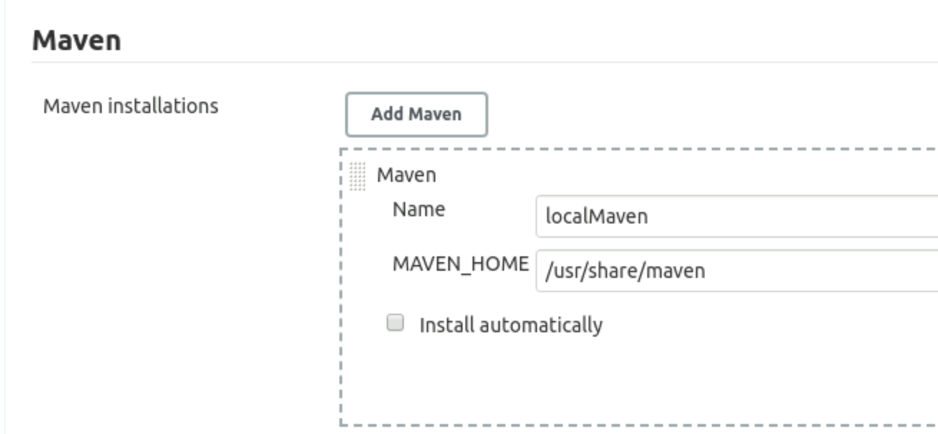

Sample maven project

<https://github.com/jenkins-docs/simple-java-maven-app>

Fork this repo into your account

Do a manual build first

git clone <https://github.com/sujee/simple-java-maven-app>

cd simple-java-maven-app

mvn compile

mvn clean package

mvn package = compile + test + package

mvn clean

mvn clean package

# Home Work - Feb 20

Lab 4.13 - Gmail integration

# Java Testing

You can use Eclipse on VM or on your laptop

<https://github.com/SimplilearnDevOpsOfficial/Lesson-04-JUnitTDD>

**Bonus lab : Unit testing + Code Coverage**

* Start by forking this project to your workspace : <https://github.com/sujee/java-testing-coverage>
* git clone your_newly_created_project
* In Eclipse : Import as Maven → Existing maven project
* Run THe Junit test as Coverage As → Junit
* Observe test coverage of various classes
* Write more tests to increase coverage
* Run a maven build and look at coverage report (under target/site/jacoco)
* Setup the project within Jenkins
* and when you check in new code or test , have jenkins run a build + test + coverage
* Observe test coverage within jenkins (dashboard → project → workspace → target ….)